Modern Machinery Hydraulic Skyline System

Software Download Instructions

Before connecting the hardware to your computer, you will need the IFM Maintenance Tool. Follow these steps:

Step 1. Download the Maintenance Tool from <https://www.ifm.com/us/en/downloadarea/R360Content>. You may need to create an account to download. Make sure you select ‘Maintenance Tool inkl. CANfox driver’.

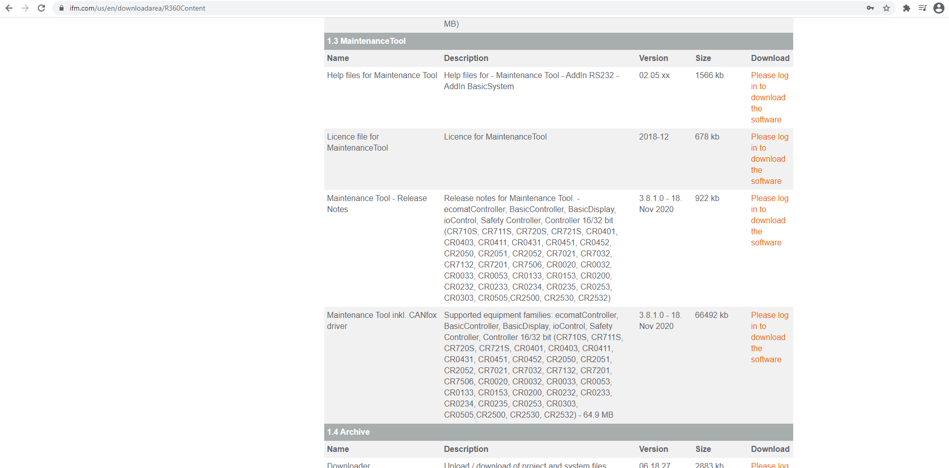

Step 2. Once downloaded, unzip the contents, and install the Maintenance Tool by double clicking ‘Setup’.

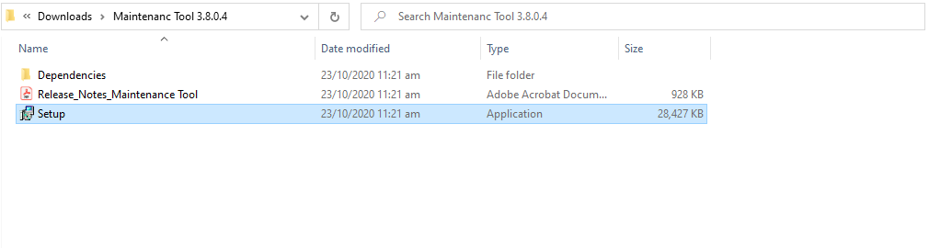

Step 3. Once the Maintenance Tool has installed, open it by double clicking the application on your desktop.

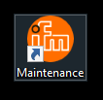

Step 4. You should see this screen. Select ‘Basic System’…

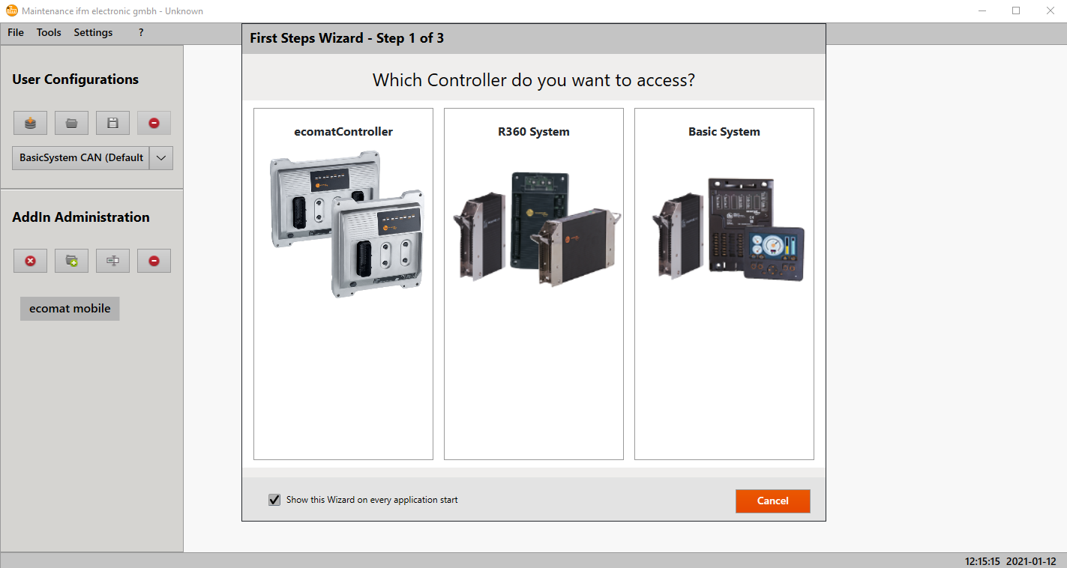

Step 5. Then select ‘CAN’…

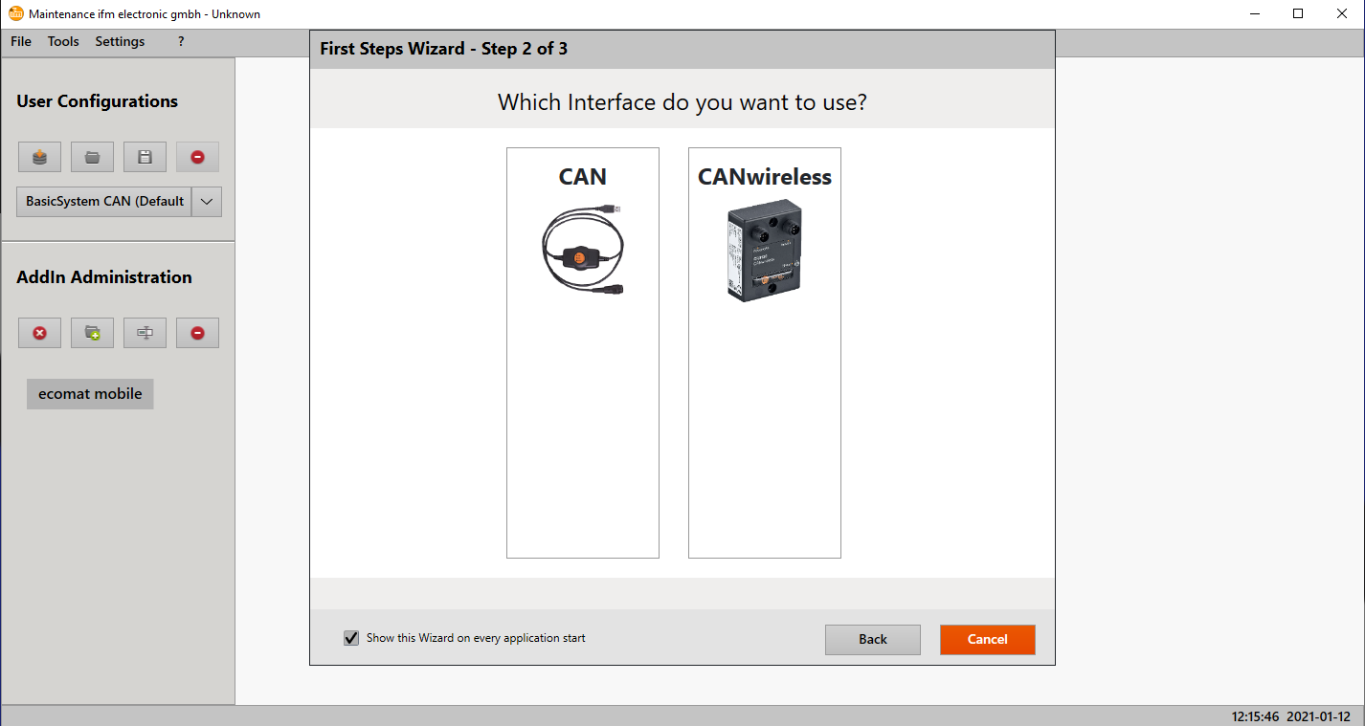

Step 6. Then close the wizard.

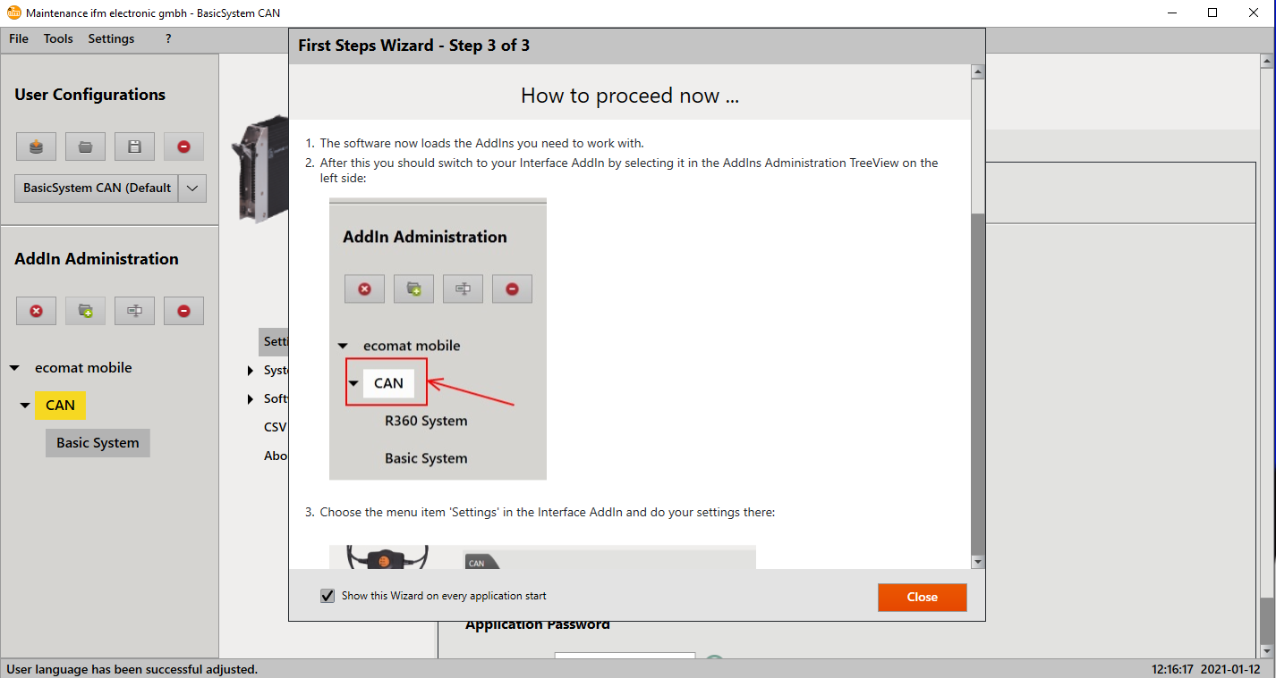

Now that you have the Maintenance Tool, connect the hardware to your computer via USB and supply power to the hardware.

To check the connection, go to System Information>Ping and type 127 as the Node ID. When you click ‘Send’ the name and version fields should appear. If not, contact DCE for help.

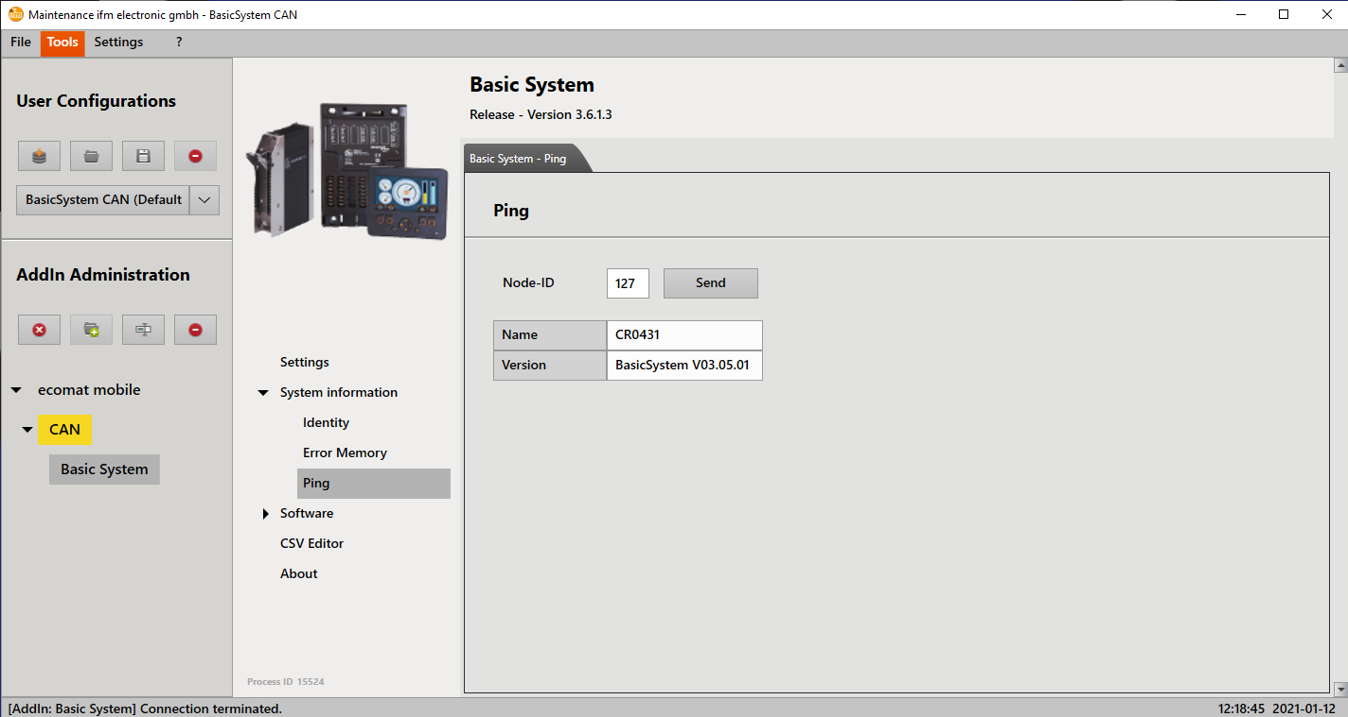

The node ID’s for the hydraulic skyline system are 120, 125, and 127 (CR0451, CR0403, and CR0431 respectively). Go to Settings and ensure that the Node ID is set to 127 and then follow these steps:

Step 1. Go to Software>Load and click ‘Open File’.

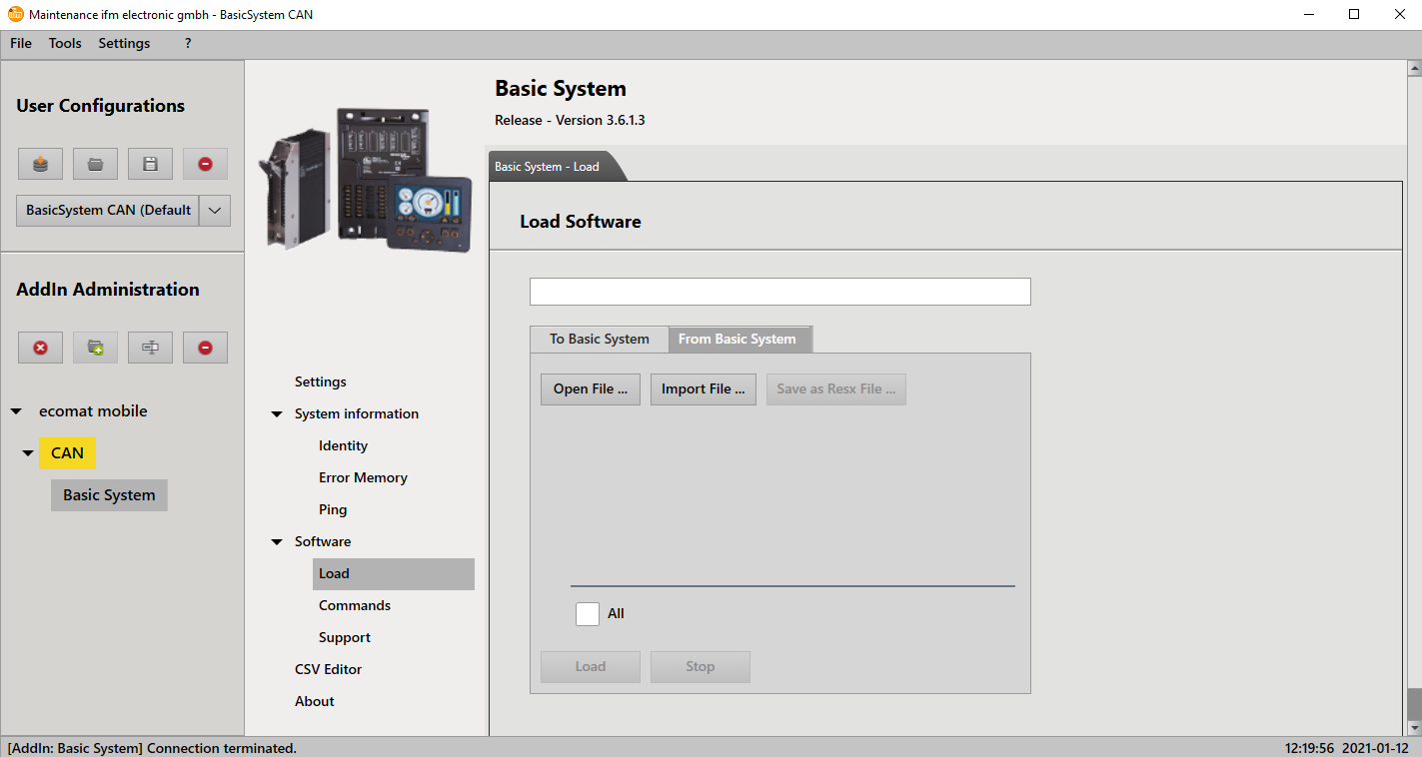

Step 2. Navigate to the file ‘Software_node127.resx’ that you downloaded earlier and open it.

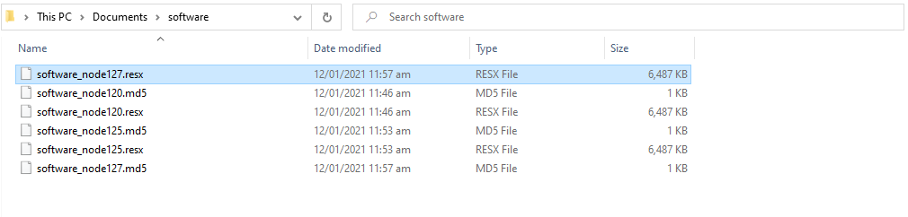

Step 3. You should now see the following programs. Tick them all and click ‘Load’. It may take a few minutes.

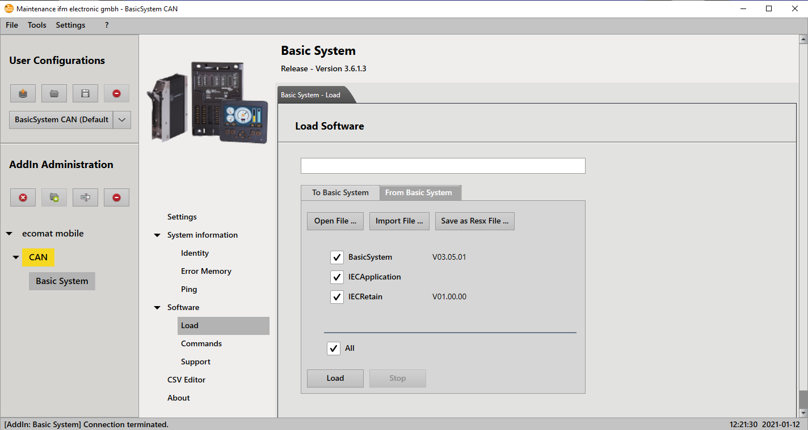

Step 4. Once the downloads are complete, go to Software>Commands and click ‘Start’.

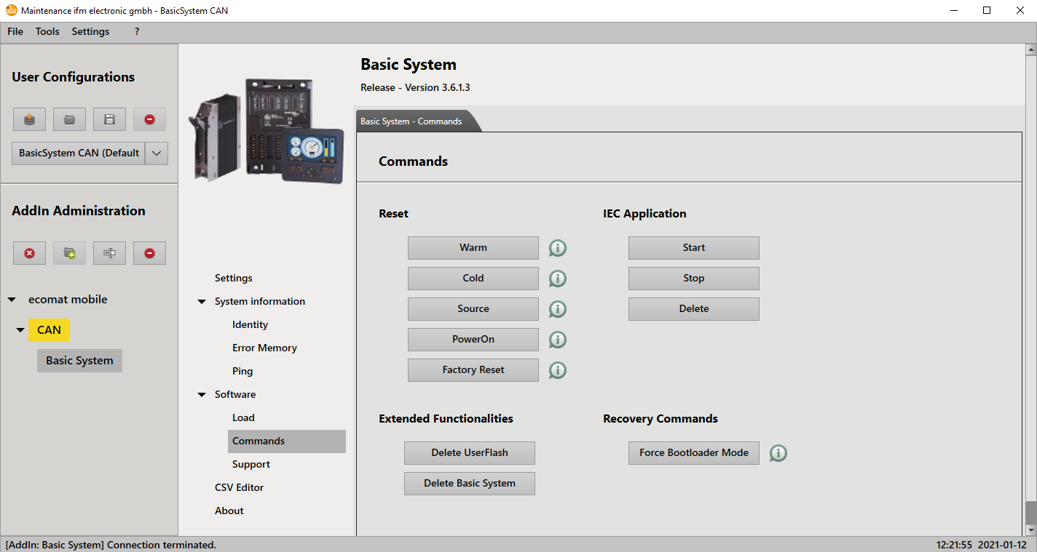

Repeat Steps 1-4 for nodes 120 and 125 by changing the Node ID on the Settings page and opening the corresponding resx file.